The Rhetoric of Coal Assignment

“Being part of a coal economy is a complicated, conflicting thing. While proud of our coal-mining heritage, we both became keenly aware at an early age of the price that had to be paid for giving energy to the nation and the world.
We both know about the love-hate relationship many Appalachians feel about coal mining. We’ve not only seen it, we’ve lived it.”
---Silas House and Jason Howard in Something’s Rising, Appalachians Fighting Mountaintop Removal
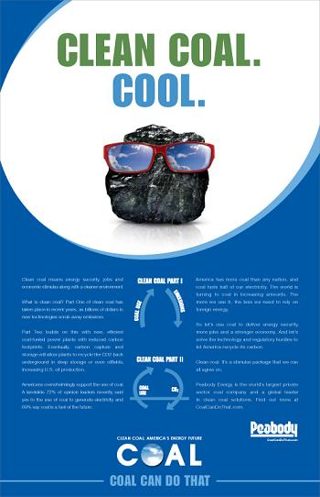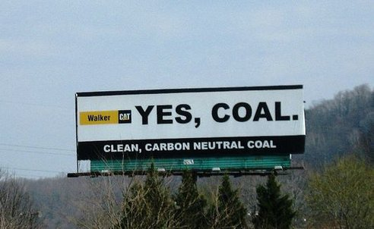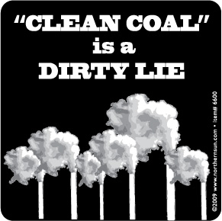

For this project we are going to examine the rhetoric surrounding the production and distribution of coal in Appalachia. For this project, I want you to come away with an understanding of the rhetoric surrounding coal. I also want you to discover a new way of expressing your critical thinking through this knowledge in a visual and/or audio medium.
We will need to look at rhetoric behind the “Clean Coal” ads, the “I Love Mountains” ads as well as the media coverage of recent coal mining disasters. Working our way through this understanding we will develop our own archive and definitions of coal and it’s appearance in our popular culture.

Disclaimer: I know that this topic will spark some lively conversation. Let’s please be respectful to one another and understand our differences.

First Step:
I would like for you to locate
1 website
1 multimedia example (youtube clip, advertisement, film clip, etc. anything VISUAL)
1 “hard source” i.e. a scholarly article or a chapter of a book

Each of these sources must have something to do with the production of coal in the Appalachia region and must have occurred from 2010-2014.

After you have located your three sources I would like for you to do a brief annotated bibliography on each of them. For this bibliography you should first list the source in MLA documentation style and then give me a brief summary and purpose for each text. As you address the purpose please make use of our “key terms” that we talked about in class.

Due to be uploaded Monday, February 9th

Second Step:
For the next step in this project I would like for us to synthesize these articles and start to create your own archives of Coal Rhetoric. I would like for you to get into groups of 3 and look at the texts that you have found.

- Look at the commonalities and differences in how these articles address and treat coal.
- Look at the points that these writers are making.
- Are they valid?
- Are there logical fallacies?
- What appeals do they depend on?
- What exigence do they demand?
- How does context play a role?

After doing this for your articles, I would like to group your texts by ideas that they share. Think of how they rationalize their arguments then look for commonalities or differences.

The product that I’m looking for here is a list of the arguments made by each text with an explanation under each.

Due to be uploaded Wednesday 2/19

Step Three
After you have discussed this with your group and started to synthesize common traits and ideas that are presented here I would like to for you to transfer these ideas into a digital sphere. We are using this style of communication so that you will learn more about constructing ideas in a digital platform. You will be producing a 2-3 minute multi-modal project. You can use the following mediums to express your findings:
- Prezi
- Short youtube film
- Vine
- Podcast
- 4-5 Vimeo videos
- Storehouse App.
- Any other visual or audio medium that you pass by me
These visual presentations should explain what you have found through examining the texts in your group. Think about common threads that run through each of the articles and organize your project through that instead of a chronological listing or summary of each article.

In addition to this digital product, I would also like a one-page single spaced reflection document on the choices that you made in your project. In this reflection I also would like for you to reflect on how each group member contributed.

Project Outline Due at Group Conferences (Monday 2/24, Wednesday 2/26, and Friday 2/28)
Final Project will be due at the Student Symposium on Writing Wednesday, 3/26

